The University of Szczecin is the biggest higher education institution in north-west Poland. It was founded on 1st September 1985 through the merger of three education institutions - Academy of Commerce, Faculty of Engineering and Economics of Technical University and Higher School of Pedagogy. The University can boast full academic autonomy; its faculties have the right to confer the titles of Bachelor, Master, Doctor, Assistant-professor and Full-professor.
The University of Szczecin employs over 1,100 academic teachers and educates 20 thousand students, who are following full-time, evening and part-time studies in 37 subject areas at 7 faculties:
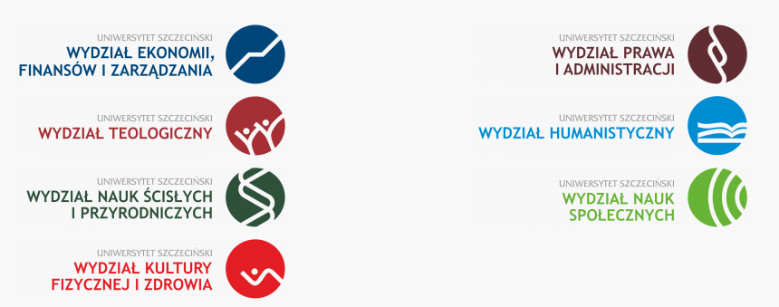

The Faculty of Economics, Finance and Management of the University of Szczecin has good traditions in the field of economics, finance and management.
We can boast the longest teaching and research traditions in Pomerania. Its beginning can be traced back to the year 1946 when the Faculty existed as a division of the Poznan Academy of Commerce.
In 1950 the School of Economy located in Szczecin was separated from the Academy. 1985 is a breakthrough date since it was then that the University of Szczecin and the Faculty of Economics within the University were established.
In 1997 the faculty was renamed to the Faculty of Economics and Management. Bearing in mind our long tradition, we aim invariably at the development of our research potential, constantly improving the level and extent of education.

In 2019 the faculty was renamed to the Faculty of Economics, Finance and Management. Three Institutes (Institute of Economics and Finance, Institute of Management, Institute of Economic Geography and Spatial Economics) and about 300 scientific workers are connected with the Faculty.
Up till now the Faculty has promoted approximately 30,000 MSc in economics and has granted more than 400 PhD degrees in economics.
At the moment we are educating over 3 500 students in full-time and part-time studies offered as the Bachelor's degree and Master's degree programmes.

- Dziennikarstwo i zarządzanie mediami II
- Economics and IT Applications
- Ekonomia
- Ekonomiczno-Prawny
- Finanse i Rachunkowość
- Gospodarka Nieruchomościami
- Informatyka i Ekonometria
- Informatyka w biznesie
- Przedsiębiorczość i Inwestycje
- Public Management
- Rynek Nieruchomości
- Zarządzanie
- Zarządzanie i Inżynieria Produkcji
- Logistyka
- Gospodarka przestrzenna
- Turystyka i rekreacja
- Journalism and media management II
- Economics and IT Applications (bachelor)
- Economics
- Economics and Law
- Finance and Accounting
- Real estate management
- Information technology and econometrics
- Computer science in business
- Entrepreneurship and Investments
- Public Management (MSc.)
- Real Estate Market
- Management
- Management and Production Engineering
- Logistics
- Spatial management
- Tourism and recreation

For graduates the Faculty provides a wide range of post-graduate studies, Master of Business Administration programme, as well as doctoral studies.
The conference ICABE is co-organized by the Faculty of Economics. Finance and Management, and two mentioned above Institutes: Institute of Economics and Finance, Institute of Management.

